**Model: YC-W716FAHBB56A**

**HD 6MP Human Body/Vehicle Detection IR Waterproof Dome PoE IP Camera**

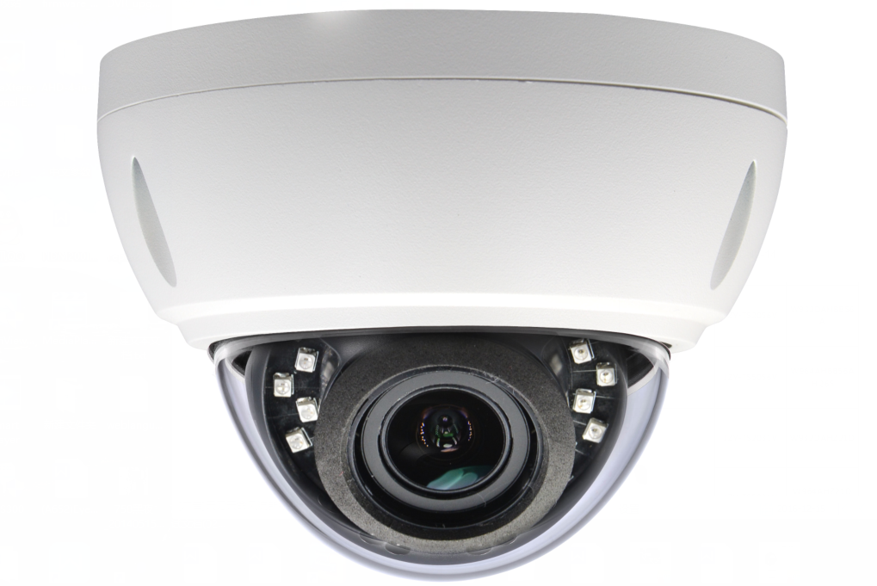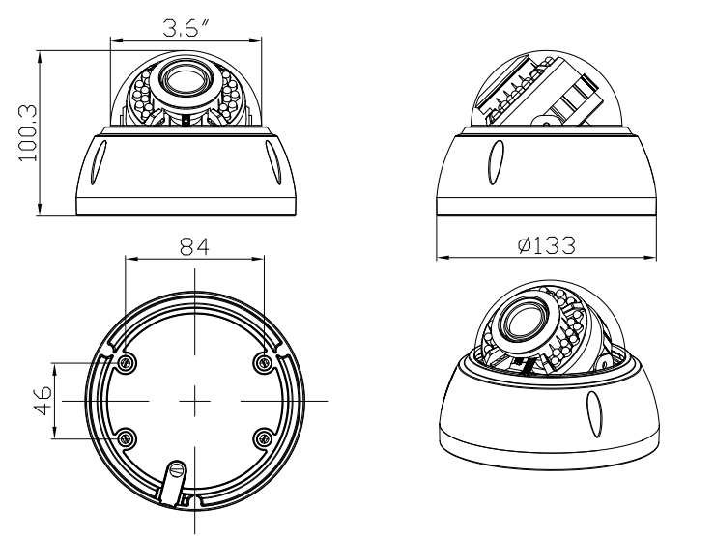





**Features:**

* 1/2.8" Sony IMX335 CMOS sensor
* 6MP HD resolution 3072 x 2048 output
* Ultra low illumination 0.01Lux
* Day/Night (ICR), AWB, 2D/3D-DNR, IR-CUT
* D-WDR, Motion Detection, Human/Vehicle Detection, Privacy Mask, Flip
* RTSP and Onvif 17.06 compatible
* H.265/H.264 dual-stream media server
* Easy-to-use P2P Cloud service
* Multi web browser, PC Client, mobile APP remote access
* RJ45 100mbps network port, IEEE802.3af PoE
* Lightning protection 4000V
* Strong water-proof housing, IP66
* 18pcs SMD IR LEDs, IR distance 20-30 meters
* HD 2.8-12 mm varifocal lens

**Technical Specifications:**

|  |  |
| --- | --- |
| **Model** | **YC-W716FAHBB56A** |
| **Camera** | |
| Image Sensor | 1/2.8" IMX335 CMOS |
| Effective Pixels | 3072(H)×2048(V) |
| Electronic Shutter | AUTO/Manual: 1/10s ~ 1/10000s, shutter threshold |
| Min. Illumination | 0.01Lux@F1.2(AGC ON), 0Lux IR on |
| Day/Night | Auto/Color/(B/W)/Timing |
| WDR | Digital WDR / HDR |
| White Balance | Auto/Manual |
| BLC/HLC | Support |
| DNR | 2D/3D DNR |
| Light Control | Auto/Manual, Mode switch, Brightness level, OFF, Light ON Illumination |
| License Plate Mode | Yes |
| Other | Multi-lines OSD, Custom Title, Privacy Mask, Flip |
| **Encode** | |
| Embedded Solution | SSC377D |
| Video Standard | H.264/H.265/H.265+ |
| Video Resolution | Main Stream: 25fps@6MP(3072x2048)/5MP(2592x1944), 30fps@4MP/3MP/1080P/720P  Sub stream: 30fps@D1/VGA/360P/CIF, etc. |
| Video Bitrates | 512Kbps - 8Mbps, VBR/CBR |
| Audio Standard | G.711-u/G.711-a/AAC |
| Built-in Mic/SD Slot | Optional |
| **Smart Detection** | |
| Motion Detection | Support |
| Target Detection | Human and Vehicle Detection |
| **IR Led** | |
| IR Led | 18pcs SMD IR LEDs |
| IR Distance | 20-30 M |
| **Lens** | |
| Focal length | 2.8-12mm varifocal lens |
| **Language** | |
| English, simplified Chinese, Chinese Traditional, Deutsch, Italian, Turkish, Polish, Korean, Japanese, Russian, Ukrainian, Persian. | |
| **Network Services** | |
| Protocol | HTTP/RTSP/FTP/NFSv3/SMTP/DHCP/NTP/RTMP, etc. |
| P2P | Yes |
| Web | IE, Firefox, Chrome, Edge, Safari, etc. |
| Media | CMS, Android, IOS |
| ONVIF | 17.06 compatible |
| **General** | |
| Network Port | 1-RJ45, 100Mbps |
| Power Supply | 12 VDC ± 10% |
| POE | 802.3af/at 48V |
| Power Consumption | < 8 W |
| Operating Temp. | -30℃-(+60)℃, 10%-90%RH |