Model: W728ADZ56FA
Dual light source 8MP@30fps 4K UHD Bullet POE IP camera
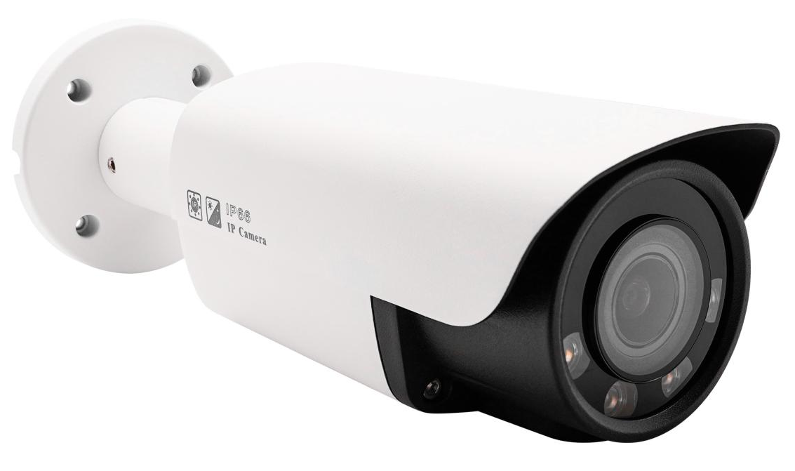

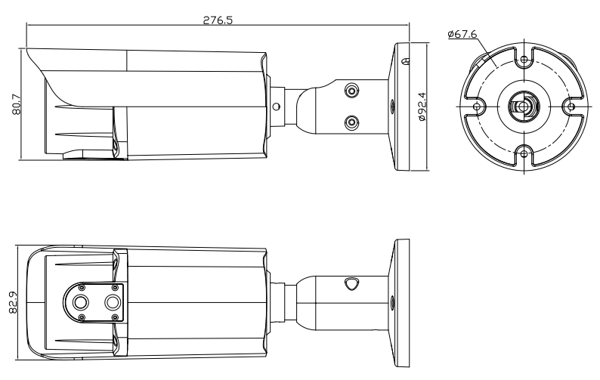

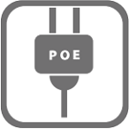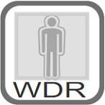

Features:
- 1/2.8" Sony CMOS sensor
- 4K resolution 3840 x 2160P
- Low illumination 0.01Lux
- Day/Night, AWB/MWB,BLC, HLC, 2D/3D-DNR,Shutter, IR-CUT
- D-WDR,Mirror, rotate, Defogging
- Multiply Style OSD Overlay,Motion Detection, Privacy Mask
- RTSP and Onvif 17.06 compatible with many third-party NVR
- H.264/H.265 dual-stream media server
- Easy-to-use P2P Cloud service
- Support user authentication, video data encryption
- Support Alarm Snapshot to Email and FTP
- Multiply WEB browser IE,Firefox 32bit ESR, PC Client, Mobile APP remote access
- RJ45 100mbps network port, IEEE802.3af PoE
- Lightning protection 4000V
- Strong water-proof housing, IP67
- 4PCS IR& Warm dual Light LEDs,Light Distance:30-40M
- 2.8mm F1.6 fixed lens
- Built in microphone optional

Technical Specifications:
Model | W728ADZ56FA
Camera
Image Sensor | 1/2.8" Sony CMOS
Effective Pixels | 8 megapixels
Electronic Shutter | AUTO, 1/25s ~ 1/100000s
Min. Illumination | 0.01Lux@F1.2(AGC ON), 0Lux IR on
Day/Night | Auto/Color/(B/W)/Timing
WDR | Digital WDR
White Balance | Auto/Manual
BLC /HLC | Support
DNR | 2D/3D DNR
License Plate Mode | Yes
Other | Human body and Vehicle detection,AGC,Motion Detection,Privacy Mask,Flip,Rotate,,OSD overlay
Encode
Video Standard | H.264/H.265
Video Resolution | MainStream:30fps@8MP(3840x2160)/6MP(3072x2048)/5MP(2592x1944)/4MP/3MP/1080P/720P,etc.  Sub stream: 720x480/VGA(640x480)/360P/QVGA@30fps,etc.  Third stream:1080P/720P/CIF@10fps
Video Bitrates | 512Kbps - 12Mbps, VBR/CBR
Audio Standard | G.711-u/G.711-a/AAC
Built-in Mic | Optional
Built-in Speaker | N/A
SD card slot | Optional
OSD Overlay | Title and Time overlay ,custom color adjustable
LED
Led | 4PCS IR& Warm dual Light LEDs
Distance | 30-40 M
Lens
Focal length | 2.8mm F1.6 fixed lens
Language
English, simplified Chinese, Chinese Traditional, Deutsch, Italian, Turkish, Polish, Korean, Japanese, Russian, Ukrainian, Persian.
Network Services
Protocol | HTTP/RTSP/FTP/SMTP/DHCP/NTP/NFS, etc.
P2P | Yes
Web | IE , Firefox,Edge, Google Chrome etc.
Media | CMS, Android, IOS
ONVIF | 17.06 compatible
General
Network Port | 1-RJ45, 100Mbps, POE
Power Supply | 12 VDC ± 10%,POE
Power Consumption | < 8 W
Operating Temp. | -30℃-(+60)℃, 10%-90%RH

