Network Video Recorder

NVR3104

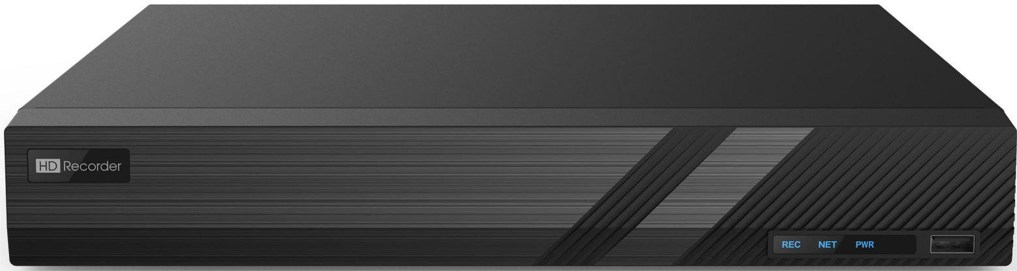

Key Features

 Support Ultra 265/H.265/H.264 video formats

 4/8/16-channel input

 Support mainstream cameras of ONVIF conformance(Profile S, Profile G, Profile T ) and RTSP protocols

 Support 1-ch HDMI, 1-ch VGA

 HDMI and VGA simultaneous output

 Up to 4K resolution recording

 1 SATA HDD up to 8TB

Specifications

|  |  |
| --- | --- |
| **Model** | **NVR3104** |
| Video/Audio Input | |
| IP Video Input | 4-ch |
| Two-way Audio Input | 1-ch, RCA |
| Network | |
| Incoming Bandwidth | 64Mbps |
| Outgoing Bandwidth | 64Mbps |
| Remote Users | 128 |
| Protocols | TCP/IP, P2P, UPnP, NTP, DHCP, PPPoE, HTTP, HTTPS, DNS, DDNS, SNMP, SMTP |
| Browser | IE(IE10/11) for Windows  Firefox (version 52.0 and above) for Windows  Chrome(version 45 and above) for Windows  Edge(version 79 and above) for Windows |
| Video/Audio Output | |
| HDMI/VGA Output | HDMI:  3840x2160/30Hz, 1920x1080p/60Hz, 1920x1080p/50Hz, 1600x1200/60Hz, 1280x1024/60Hz, |

|  |  |
| --- | --- |
|  | 1280x720/60Hz, 1024x768/60Hz  VGA:  1920x1080p/60Hz, 1920x1080p/50Hz, 1600x1200/60Hz, 1280x1024/60Hz, 1280x720/60Hz, 1024x768/60Hz |
| Recording Resolution | 8MP/5MP/4MP/3MP/1080p/960p/720p/D1/2CIF/CIF |
| Audio Output | 1-ch, RCA |
| Audio Compression | G.711A, G.711U |
| Synchronous Playback | 4-ch |
| Liveview display | 1/4 |
| Corridor Mode Screen | 3/4 |
| Snapshot | |
| FTP/Schedule/Event  Snapshot | 4-ch snapshot, up to D1 resolution |
| Decoding | |
| Decoding format | Ultra 265/H.265/H.264 |
| Liveview/Playback | 8MP/5MP/4MP/3MP/1080p/960p/720p/D1/2CIF/CIF |
| Capability | 2 x 4K@30, 3 x 5MP@30, 4 x 4MP@30, 5 x 3MP@30,8 x 1080p@30, 16 x 720p@30 |
| Hard Disk | |
| SATA | 1 SATA interface |
| Capacity | Up to 8TB for each disk  (The maximum HDD capacity varies with environment temperature) |
| Smart | |
| VCA Detection by Camera | Intrusion Detection, Cross Line Detection, Enter Area, Leave Area, Defocus Detection, Scene Change Detection, Object Left Behind, Object Removed, Auto Tracking, Ultra Motion Detection(UMD) |
| VCA Search | Behavior Search |
| People counting | People Flow Counting, Crowd Density Monitoring |
| Smart Intrusion Prevention (SIP), UMD by Camera | Total 4-ch |
| General Alarm | |
| General Alarm | Motion, Tampering, Human Body Detection, Video Loss, Alarm Input, Audio Detection |
| Alert Alarm | IP Conflict, Network Disconnected, Disk Offline , Disk Abnormal, Illegal Access, Hard Disk Space Low, Hard Disk Full, Recording/Snapshot Abnormal |
| External Interfac | |
| Network Interface | 1 RJ45 10M/100M self-adaptive Ethernet Interface |
| USB Interface | Rear panel: 1 x USB2.0,1 x USB3.0 |
| RS232 | NA |
| RS485 | NA |
| Alarm In | NA |
| Alarm Out | NA |
| General | |
| Power Supply | 12V DC  Power Consumption: ≤8 W (without HDD) |
| Working Environment | -10°C ~ + 55°C (+14°F ~ +131°F), Humidity ≤ 90% RH (non-condensing) |

|  |  |
| --- | --- |
| Dimensions (W×D×H) | 260mm × 240mm × 47mm (10.2"×9.4"×1.9 ") |
| Weight (without HDD) | 1.3kg (2.87 lb) |
| Certification | |
| Certification | CE, FCC, UL, RoHS, WEEE |
| CE | EN 55032: 2015, EN 61000-3-3: 2013, EN IEC 61000-3-2: 2019, EN 55035: 2017 |
| FCC | Part15 Subpart B, ANSI C63.4 |

Dimensions

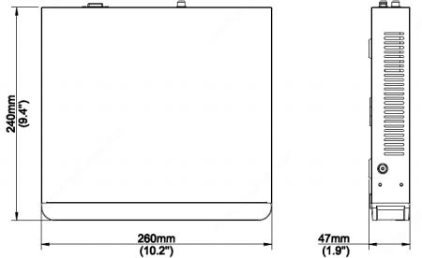

Rear Panel

USB3.0 VGA

Network Interface

Audio Output

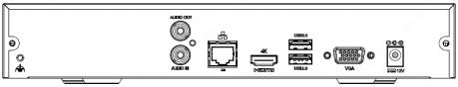GND

 Power Supply

Audio Input

HDMI Output

USB2.0