**32CH PoE NVR 12MP/8MP/6MP/5MP/4MP/3MP/1080P/720P HD PoE NVR**

Model:**NVR6432-P16-A2**

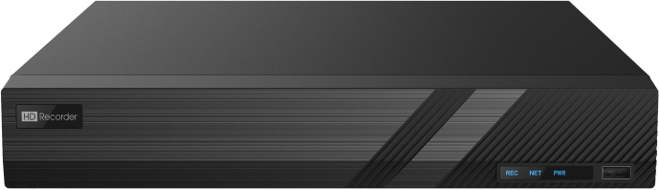

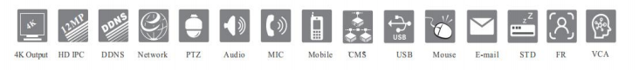

**Features**：

* Support 32CH 12MP/8MP/6MP/5MP/4MP/3MP/1080P/1280 × 1024/960P/ 720P/960H/D1/CIF IPC Input
* H.265S/H.265+/H.265/H.264
* Intuitive and user-friendly Graphic User Interface ( GUI ), Windows styleoperation by mouse
* Multi-type recording: manual / timed / motion / sensor / POS /AI recording
* Playback : 16 CH simultaneous playback
* Search : time slice, time, event, tag and smart search
* Support face detection and comparison
* Support multiple VCA(Video ContentAnalytics) events, such as object abandoned/missing, region intrusion, tripwire, video exception, etc.
* Support license plate recognition
* Support POS information overlay on live view and playback
* Pentaplex : preview, record, playback, backup and remote access
* DHCP, DDNS, PPPoE network protocol
* Compatible with third-party IPCs, such as ONVIF, Hikvision, etc.
* Remote control via Web Client or CMS : preview, playback, backup, PTZ and configuration
* Support 16CH PoE IPC direct connection to NVR via PoE ports
* Multi-user online simultaneously
* Authorization management, log view and device status view
* 4K output, true high resolution display
* Support PTZ preset and auto cruise, up to 255 presets and 8 cruises
* Support NAT function and QRCode scanning by mobile phones
* Powerful mobile surveillance by smart phones with iOS and Andriod OS

**Specifications：**

|  |  |  |
| --- | --- | --- |
| **Model** | | **NVR6432-P16-A2** |
| System | OS | Embedded Linux |
| Video | Compression | H.265S/ H.265+/ H.265/ H.264 |
| IP Video Input | 32CH IPC input |
| Resolution | 12MP/8MP/6MP/5MP/4MP/3MP/ 1080P/ 1280 × 1024/960P/720P/960H/ D1/CIF |
| Network Bandwidth | 192Mbps/ 192Mbps (incoming/outgoing) |
| Output | HDMI1 : 3840 × 2160/ 1920 × 1080 / 1280 × 1024 / 1024 × 768 |
| HDMI2 : 1920 × 1080 / 1280 × 1024 / 1024 × 768 |
| VGA × 1 : 1920 × 1080 / 1280 × 1024 / 1024 × 768 |
| VGA and HDMI1 output the same video source |
| Audio | Network Input | 32 CH IPC audio input |
| 2-way Audio | RCA × 1 |
| Local Output | RCA × 1 |
| Compression | G.711(U/A) |
| Record | Record Stream | Dual stream recording |
| Resolution | 12MP/8MP/6MP/5MP/4MP/3MP/ 1080P/ 1280 × 1024/960P/720P/960H/ D1/CIF |
| Frame Rate | NTSC: 30fps; PAL: 25fps |
| Playback | Simultaneous Playback | Max 16CH |
| Search | Time slice / time / event / tag / smart search |
| Smart Search | Highlighted color to display the camera record in a certain period of time, different colors refers to different record events |
| Function | Play, pause, FF, FB, digital zoom, etc. |
| Decoding Capability | Live View/ Playback | 1CH 12MP/4CH 1080P |
| Multi-Screen Display Mode | Mode | Dual output mode (default mode): supports HDMI2 output, but doesn’t support AI by device |
| AI mode : HDMI2 output and 12MP video input (live view/playback)are unavailable, but 8MP video input supports |
| Dual Output Mode | 32CH (HDMI1) +4CH (HDMI2) |
| AI Mode | 24CH (HDMI1) |
| Alarm | Mode | Manual, sensor, motion, exception, smart events, etc. |
| Input | 16 CH local alarm input |
| Output | 4 CH |
| Triggering | Record, snap, preset, e-mail, etc. |

|  |  |  |
| --- | --- | --- |
| Face | Face Detection Performance (AI by IPC) | 32CH |
| Face Detection Performance (AI by Device) | 2 CH (2MP) |
| Face Match Performance | 6 CH |
| Comparison Capability | 18 pictures / second |
| Face Picture Database | 32 libraries |
| 10000 Face Pictures |
| Face Picture Search | Search by picture is supported |
| Database Management | Add, modify, delete and search face pictures |
| Face Picture Adding | Add face pictures through APP, WEB and external import |
| Face Picture Comparison | Support allow list, block list and stranger match alarm |
| Track | Track display on a map |
| Statistical Graph of  Information | Bar graph |
| Statistical Mode of  Information | Statistics by day, week, month, quarter as well as customized time period |
| Video Structure Analysis | Human/Vehicle Classification | Yes |
| Other Functions | Fisheye | Supports fisheye dewarping via Web Client and mobile APP |
| Plate Recognition | Yes |
| Network | Interface | RJ 45 1000 Mbps × 2 |
| Protocol | TCP / IP, PPPoE, DHCP, DNS, DDNS, UPnP, NTP, SMTP, HTTP, HTTPs, 802.1x, RTSP, SNMP, ONVIF |
| Client Connection | Max. 20 users access |
| PoE | PoE Port | RJ 45 100Mbps × 16 |
| Standard | IEEE802.3AF/AT |
| Output Power | ≤ 150W |
| Mobile Device | OS | iOS, Andriod |
| Storage | HDD Interface | SATA × 4, max 10T for each HDD |
| E-SATA Interface | E-SATA × 1 |
| Backup | Local Backup | U disk, USB mobile HDD |
| Network Backup | Yes |
| External Interface | RS 485 | Yes (full-duplex), connect to PTZ or keyboard |
| USB | USB 3.0 × 1 ; USB 2.0 × 2 |
| Others | Power Supply | ATX 300W(PoE) |
| Consumption | ≤ 20W ( without HDD and PoE power supply ) |
| Certificate | CE, FCC |
| Environmental Protection | Complies with Directive EU RoHS, REACH and WEEE |
| Dimensions(mm) | 440 × 390 × 70( W × D × H ) |
| Working Environment | - 10 ～ 50 ℃ , 10% ～ 90% humidity |

**Rear Panels:**

**NVR6432-P16-A2**

